**Nama : Ibnu Rusdianto**

**Kelas : Full Stack 1**

**Tugas : Sesi 20 - Kamis, 05 Okt 2023 – MysQL**

**Link Youtube (Penjelasan Query) :** [**I am a just a poor programmer**](https://anonymfile.com/pqBJ/apotek-1.sql)

**Link Youtube (Penjelasan SQL Join) :** [**I am a just a poor programmer**](https://anonymfile.com/pqBJ/apotek-1.sql)

**Download file .sql Apotek :** [**Apotek.sql**](https://anonymfile.com/o8A7/apotek-2.sql)



1. Query Insert

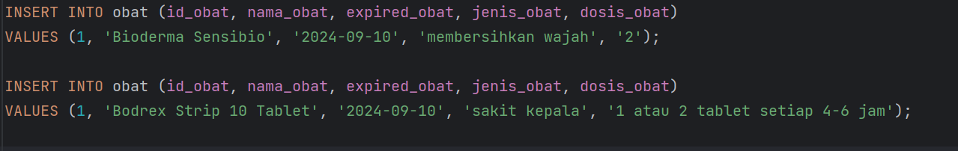

1. Query Update

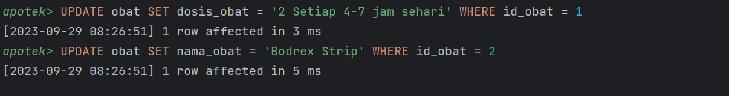



1. Query Delete

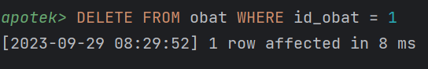

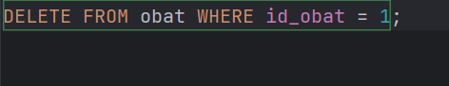

1. SELECT Query

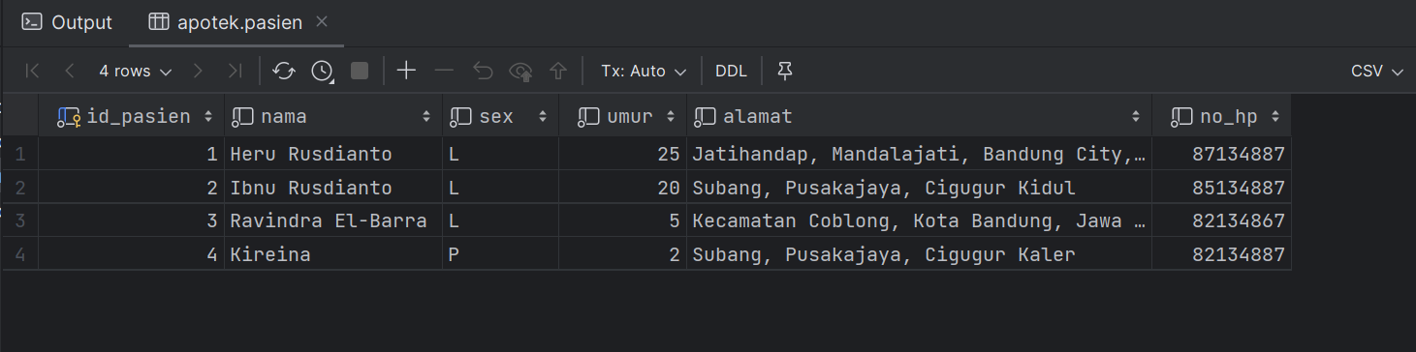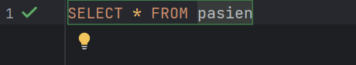

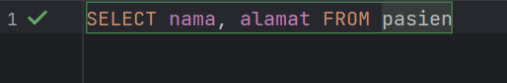

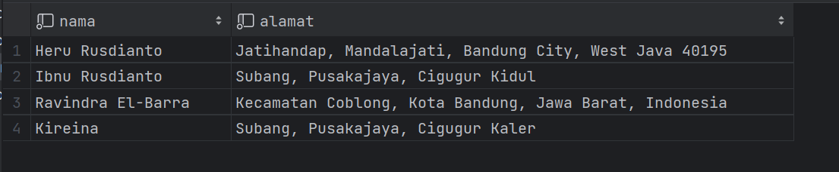

1. WHERE Query

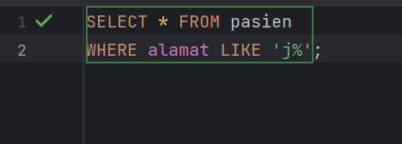

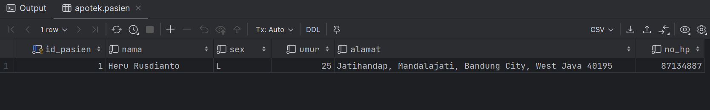

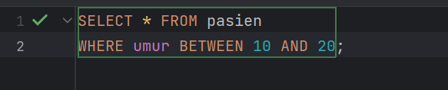

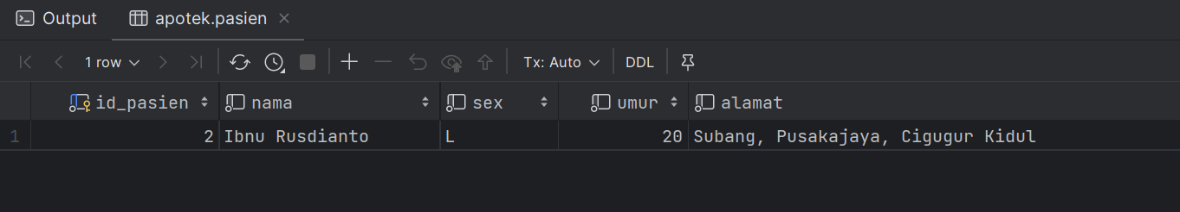

1. AND Query

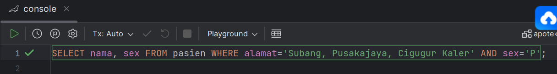

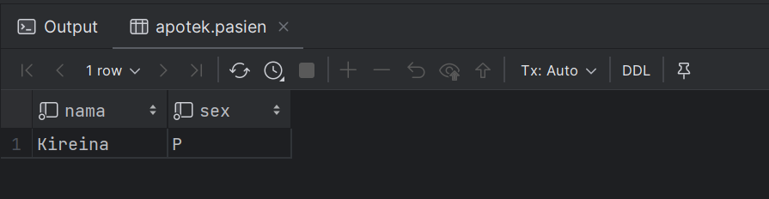

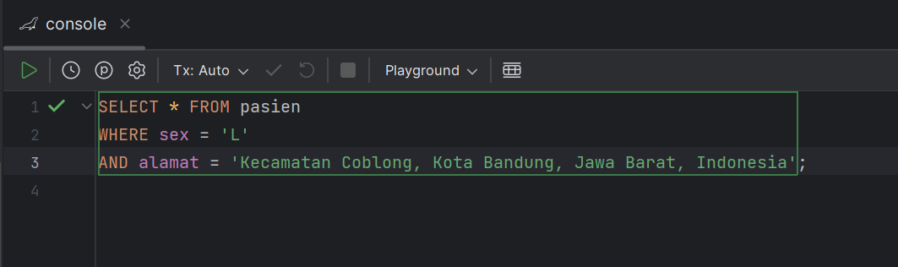

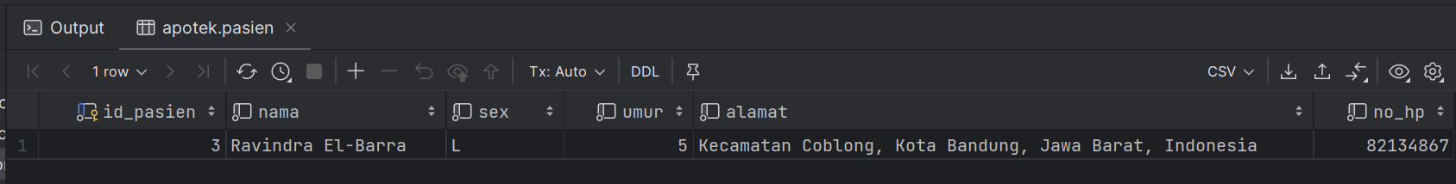

1. Sintak OR Query

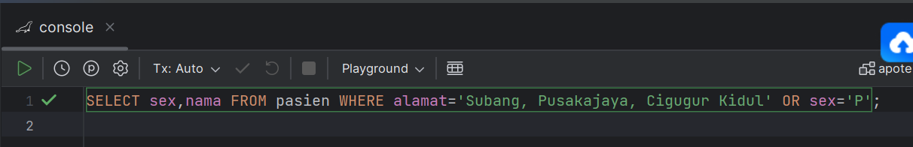

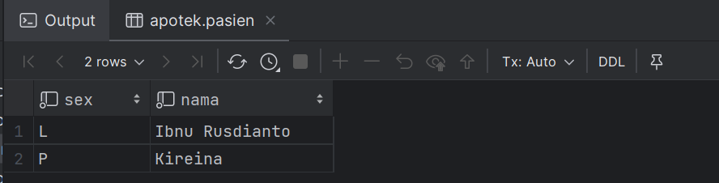

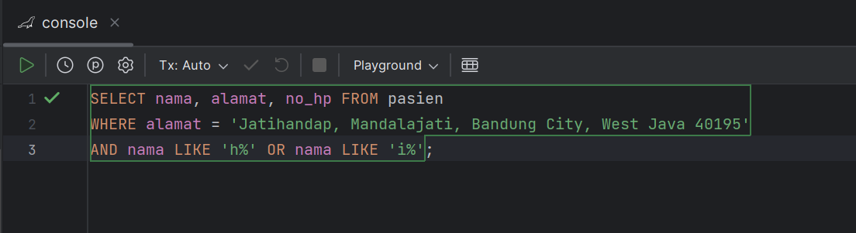

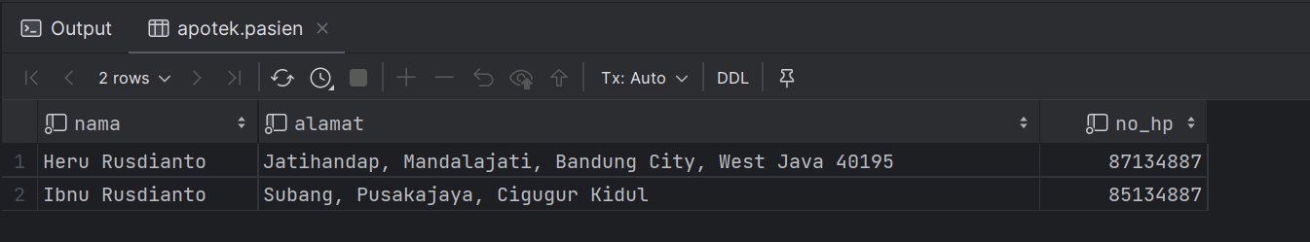

1. WHERE NOT Query

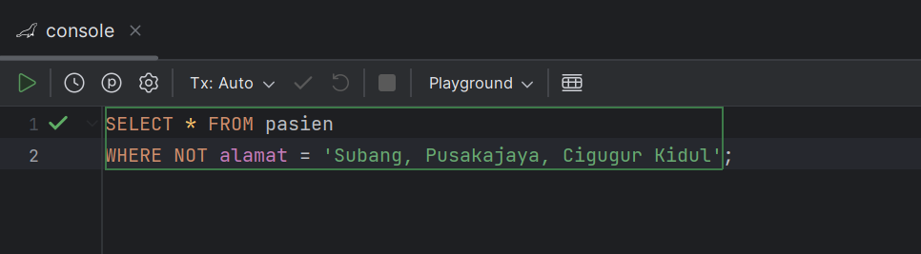

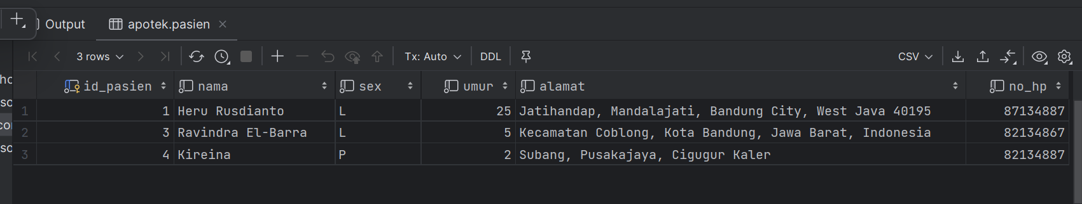

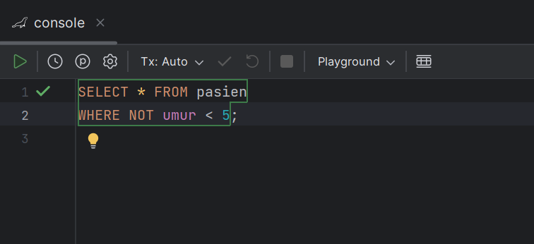

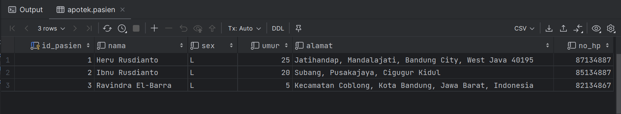

1. ORDER BY Query

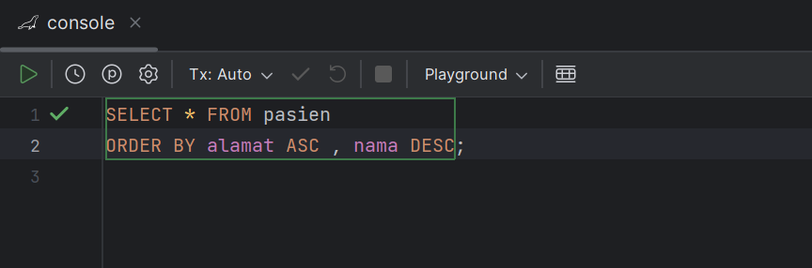

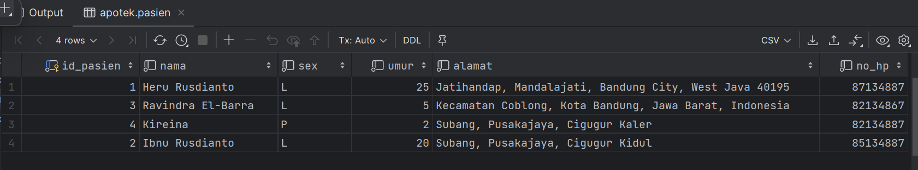

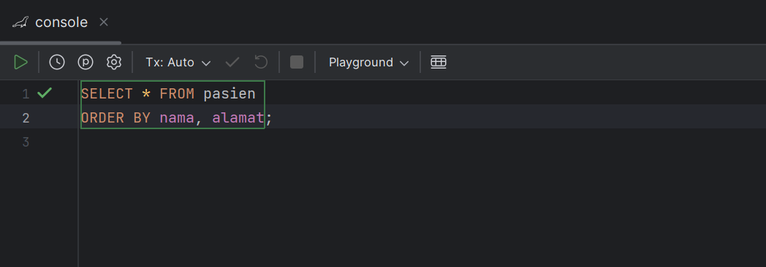

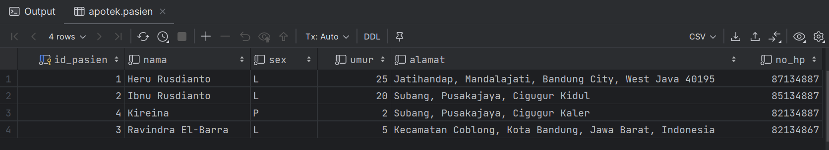

1. MIN Query

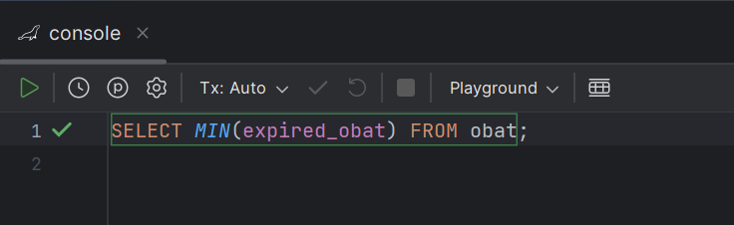

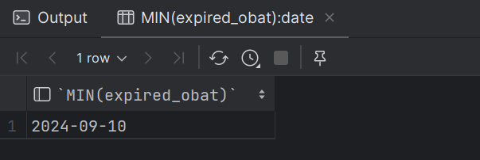

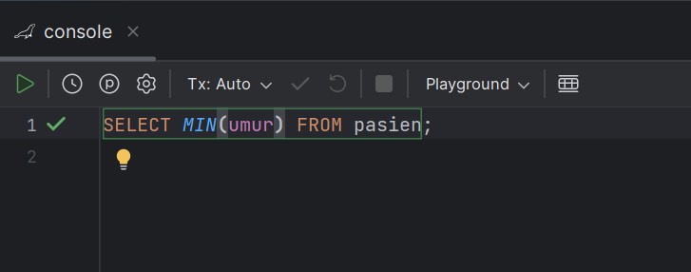

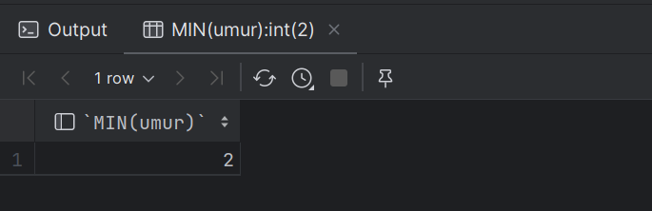

1. MAX Query

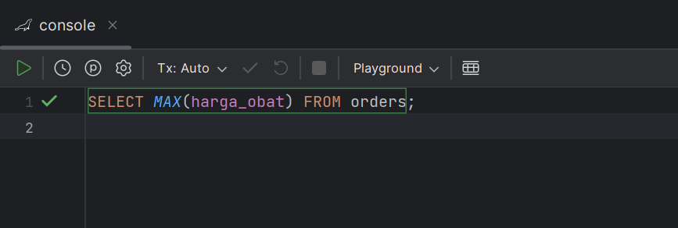

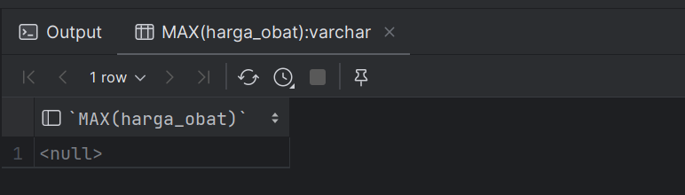

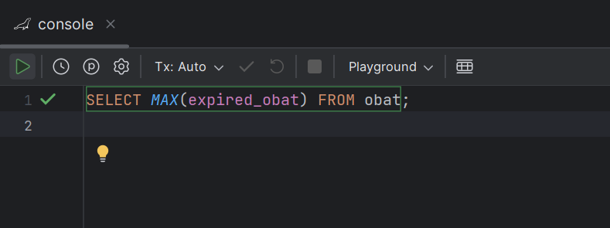

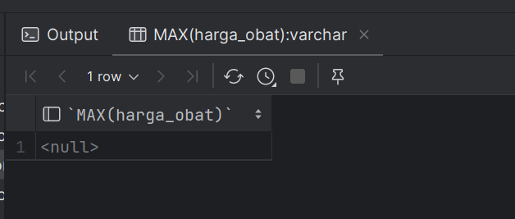

1. COUNT Query

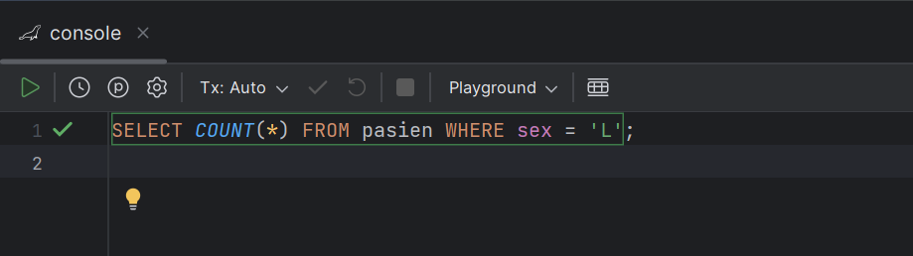

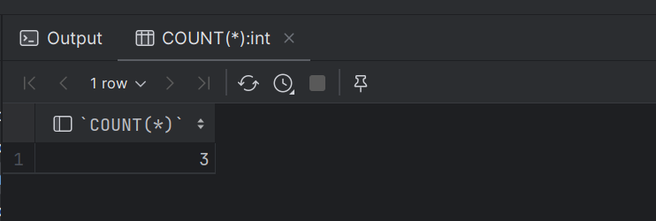

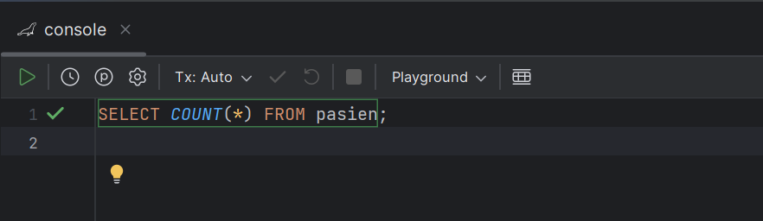

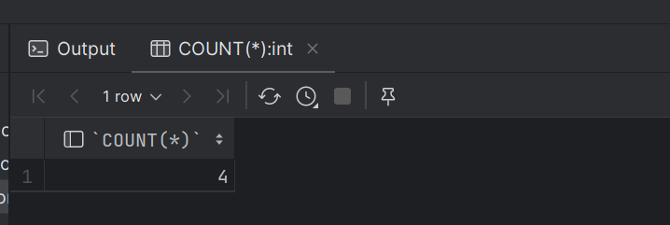

1. AVG Query

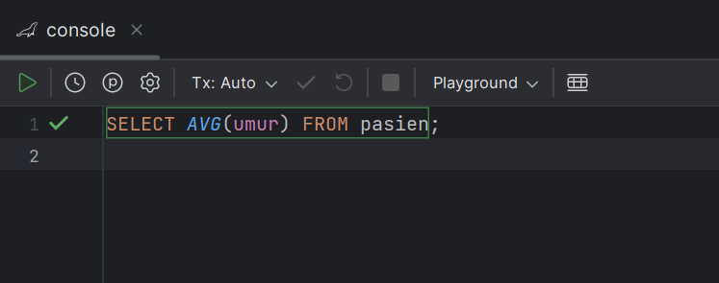

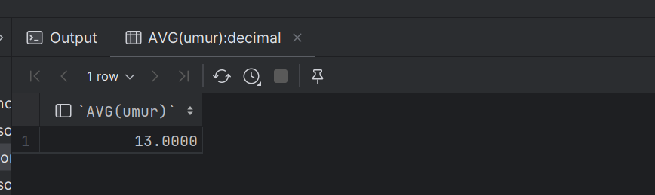

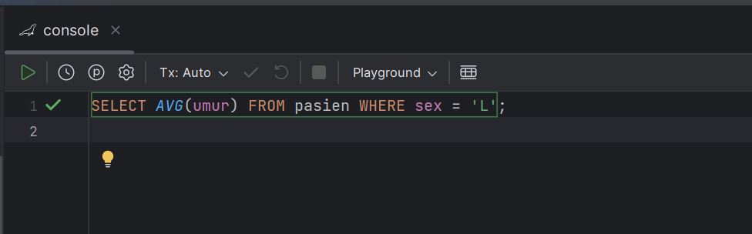

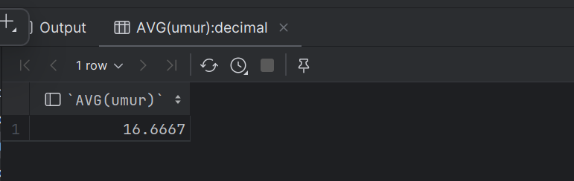

1. SUM Query

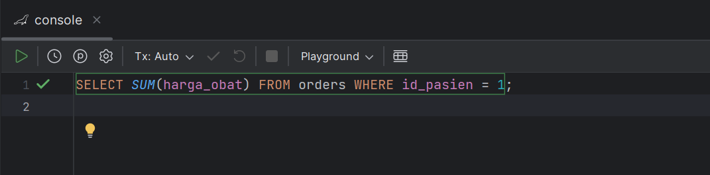

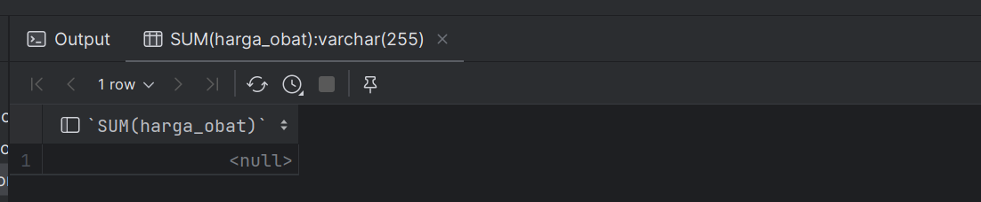

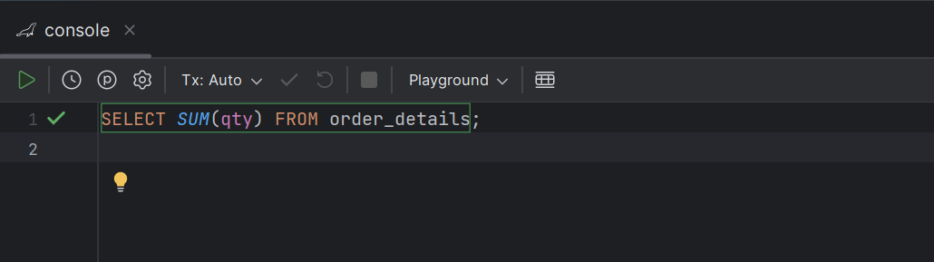

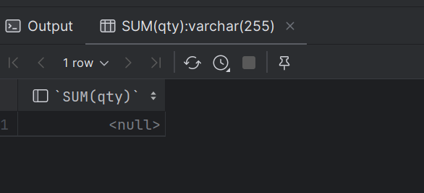

**SQL JOIN QUERY**

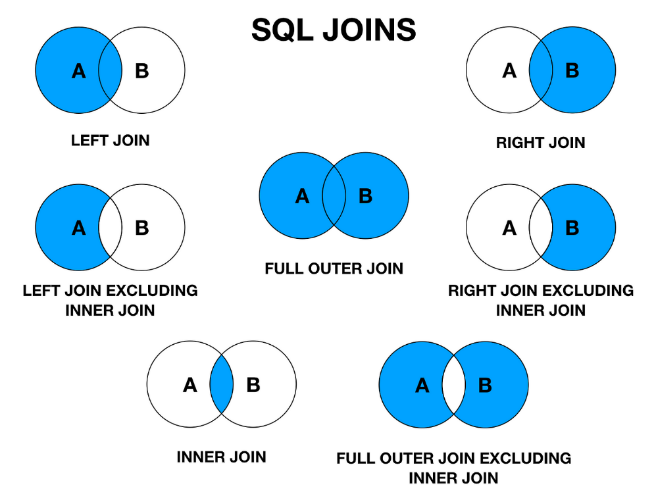

1. Inner Join antara orders dan pasien berdasarkan id_pasien

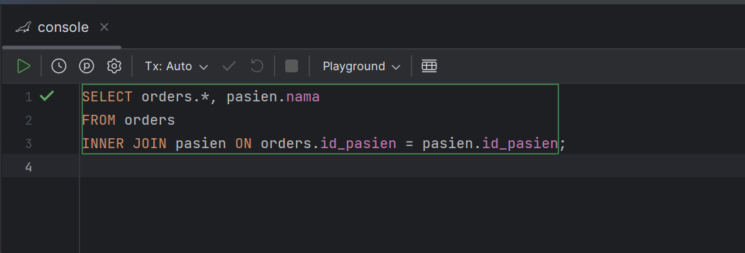

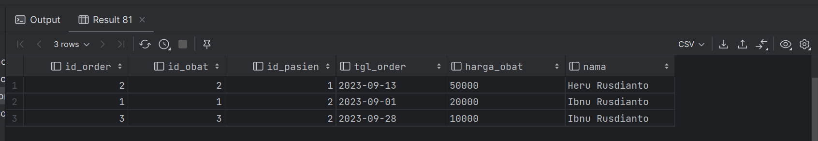

1. Left Join antara orders dan order_details berdasarkan id_order

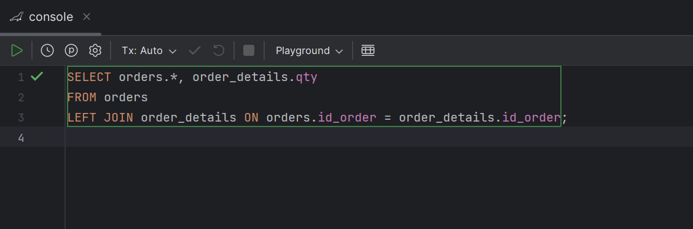

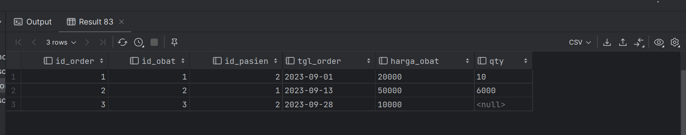

1. Right Join antara orders dan order_details berdasarkan id_order

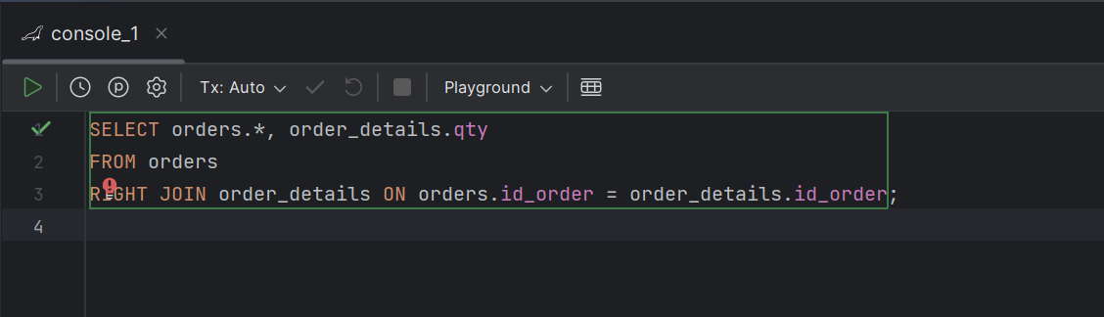

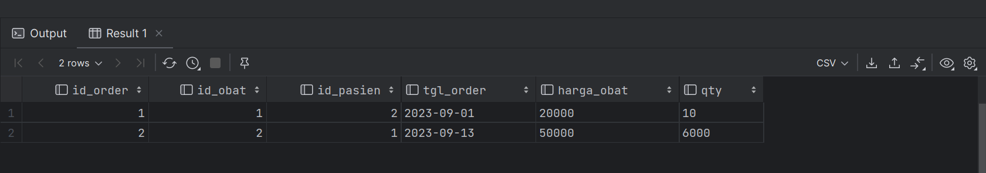

1. Inner Join antara order_details, orders, dan obat berdasarkan id_order dan id_obat

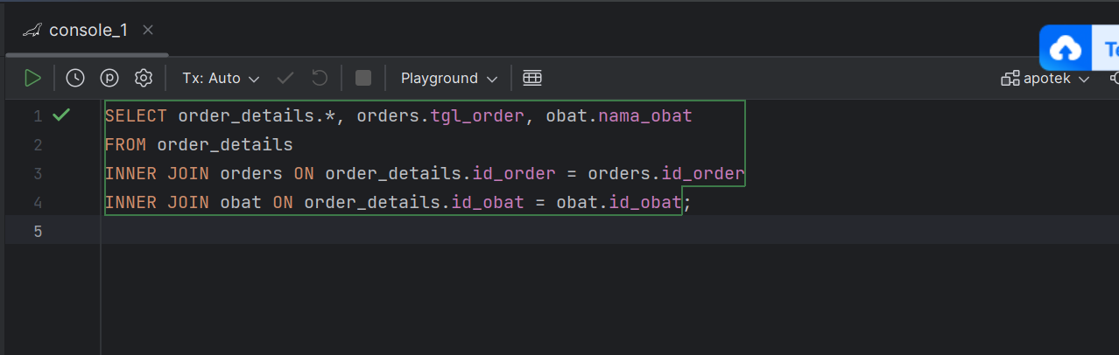

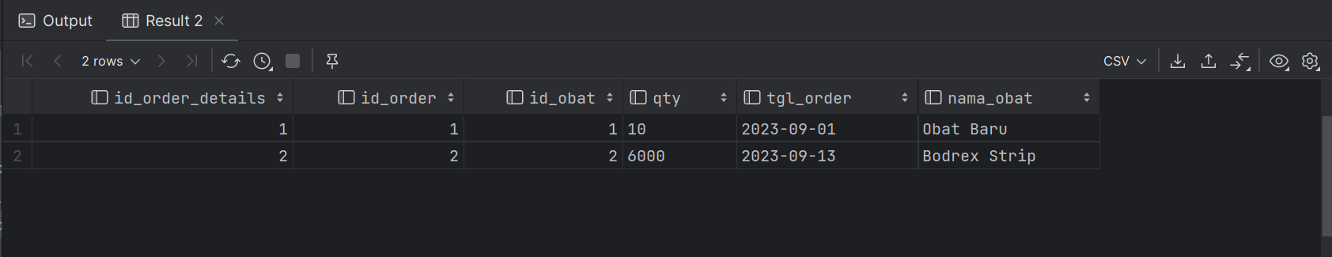

1. Menggabungkan LEFT & RIGTH JOIN Dengan Metode UNION

